

Alert Manager Enhancements

Technical Specification

Version: 1.2

Issued: 23 Sep 2014

#### Document Version History

|  |  |  |  |  |
| --- | --- | --- | --- | --- |
| Version | Owner | Update Source | Date | Description |
| 1.0 |  |  | 18-SEP-14 | Document created for review |
| 1.1 |  |  | 19-Sep-2014 | Added TFS 82703 and 92732 |
| 1.2 |  |  | 23-Sep-2014 | Updated TFS 68791, 129356, 96373, 82703 |
|  |  |  |  |  |
|  |  |  |  |  |
|  |  |  |  |  |
|  |  |  |  |  |
|  |  |  |  |  |
|  |  |  |  |  |
| For review: | | | | For approval: |
| Ian Skinner | | | | Jo Bennett |
| Linesh Sorathia | | | | Rob May |
|  | | | | Colin Stewart |
|  | | | |  |

**Table of Contents**

1 Introduction 4

1.1 Purpose 4

1.2 Scope 4

*2* Exor Select 2014 5

2.1 TFS: 79020 Additional data fields from multiple tables required 5

2.2 TFS: 83530 unclear error message in "To/Cc/Bcc" field 9

2.3 TFS: 85117 Batch related fields not disabled 10

2.4 TFS: 68791 “On Update Of” Tab to only appear on Update Operation 12

2.5 TFS: 112942 Error received when deleting Alerts 14

2.6 TFS: 85226 & 99717 on saving PEM error message is raised 15

3 Exor Select 2015 16

3.1 TFS: 129356 10 new parameters into the alert email 16

3.2 TFS: 96373 Attribute conditions sequence change after saving 18

3.3 TFS: 85189 30 Second Alert: "Next Run Date" not populated 19

3.4 TFS: 92732 Sender to be picked from “From” field 20

3.5 TFS: 82703 Email alerts don’t work for Internal Non Exor user in PEM(Northants) 21

# Introduction

## 1.1 Purpose

This document defines the requirements and design for a set of enhancements to Alert Manager.

## 1.2 Scope

The enhancements have been split into two distinct groups for the following development projects:

**Exor Select 2014:** These enhancements will be released in late 2014 as a patch to Alert Manager 4.7.0.0.

**Exor Select 2015:**  These enhancements will require further analysis and design work in 2015 and will be considered for inclusion in the 4.8.0.0 release.

# Exor Select 2014

## 2.1 [TFS: 79020](http://tfs.bentley.com:8080/tfs/ProductLine/Exor%20Products/_workitems#_a=edit&id=79020) Additional data fields from multiple tables required

**Description**

Additional data fields need to be available for selection. Currently the parameters are restricted to the flexible attributes on the alert asset based on a single table (#79020). The solution needs to:

* Allow function based parameters e.g. to display the section description based on the network reference
* Allow the selection of parameters from multiple tables e.g.
  + An enquiry alert may also require section description details, contact details, asset details, inspection, defect and repair information.
  + Work order line alert may also require asset, schedule, defect and repair details

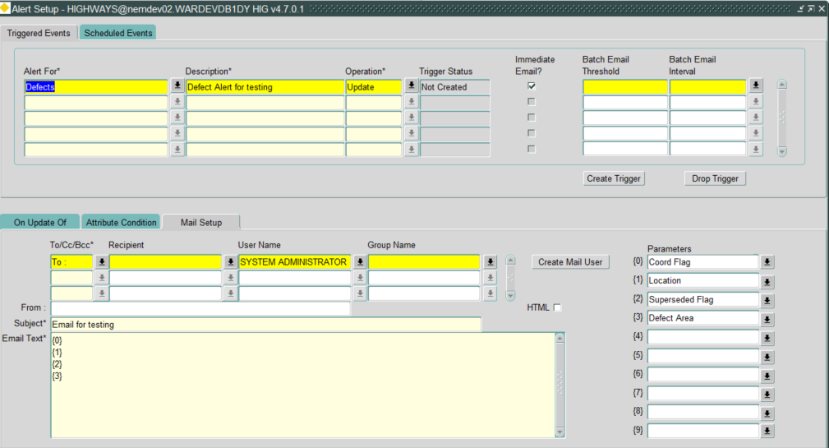

Figure

**Enhancement**

To accommodate selection of additional data fields from multiple tables and printing it in the email, we would be introducing new setup table and few additional columns in the existing Alert Type’s Mail Table.

|  |  |  |  |
| --- | --- | --- | --- |
| Sr No | Column Name | Description | Data Type |
| New Table : **HIG_ALERT_TYPE_MAIL_LOOKUP** | | | |
| 1 | HATML_ID | Primary Key Column | NUMBER |
| 2 | INV_TYPE | Asset Type or Alert For | CHAR |
| 3 | SCREEN_TEXT | Text to display in the parameter’s LOV |
| 4 | QUERY | Query to derive required information from tables other than the table connected to the Asset Type. Basically additional data required to display in email text |
| 5 | QUERY_COL | Foreign Key column used in the query to fetch additional details from multiple tables |
| 6 | CREATION_DATE | Creation Date of the record DEFAULT SYSDATE | DATE |
| Additional columns added to **HIG_ALERT_TYPE_MAIL** | | | |
| 1 | HATM_P1_DERIVED | These columns will be used to identify the parameter is Derived (i.e additional data) or from the existing Asset Type | CHAR |
| 2 | HATM_P2_DERIVED | CHAR |
| 3 | HATM_P3_DERIVED | CHAR |
| 4 | HATM_P4_DERIVED | CHAR |
| 5 | HATM_P5_DERIVED | CHAR |
| 6 | HATM_P6_DERIVED | CHAR |
| 7 | HATM_P7_DERIVED | CHAR |
| 8 | HATM_P8_DERIVED | CHAR |
| 9 | HATM_P9_DERIVED | CHAR |
| 10 | HATM_P10_DERIVED | CHAR |

* Data stored in Screen_Text field of the setup table would be appended to the data fields displayed in the existing parameter’s LOV.
* Once selection has been made, these additional fields would be marked as Derived at the backend.
* This Derived Column (HATM_Px_DERIVED) Concept would help us differentiate between same name parameters from existing Asset Type and additional table. Value stored can Y(additional data) or N
* Queries stored in the setup table would be run and to fetch additional data field’s value.
* User will see additional data fields in the parameter’s LOV if there are any entries in HIG_ALERT_TYPE_MAIL for Asset Type on which Alert has been created.

**NOTE :** This concept is designed to display single value in the email text for each additional data field selected. Multiple records returned situation would be considered in the 2015 release.

**For Example:**

We create an alert on Defects (DEF$) Asset Type and In the Setups we have below entries.



Figure 2

Under the Mail Setup Tab, When we select LOV for one of the parameter’s then it would contain 2 additional fields picked from the setups i.e Asset Description and Asset Location.

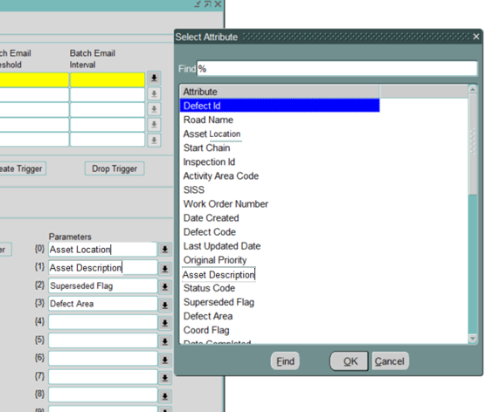

Figure

When either of them is selected, their corresponding query is run and the value returned is displayed in the email text.

**Analysis**

* **HIG_ALERT.pkb** would require changes to incorporate the Derived Columns from additional tables, fetch their values and design a trigger.

Changes would be needed for Immediate Alerts, Batch Alerts and Scheduled Alerts

* **HIG1520.fmb** Adding logic to handle the Derived Columns displayed in Parameter’s LOV and update the HATM_Px_DERIVED Columns for each value selected
* New columns added in the existing table HIG_ALERT_TYPE_MAIL
* New table created HIG_ALERT_TYPE_MAIL_LOOKUP

## 2.2 [TFS: 83530](http://tfs.bentley.com:8080/tfs/ProductLine/Exor%20Products/_workitems#_a=edit&id=83530) unclear error message in "To/Cc/Bcc" field

**Description**

HIG1520 - [General] Alert setup: appears unclear error message when you enter incorrect value to "To/Cc/Bcc" field

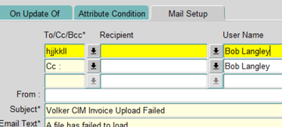

Figure 3

**Bug Fix**

We Shall validate the value entered in the field against the List of Values.

So in case we type any random value and press TAB or try to navigate to another field then the LOV of the TO/CC/BCC field would pop up and you have to then select value from the presented list.

Screenshot below depicts the same scenario:

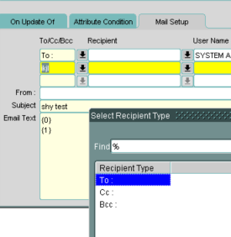

Figure 4

**Analysis**

Form **HIG1520.fmb** would be updated.

Field *HATR_TYPE ,*

*Property Validate from List*

## 2.3 [TFS: 85117](http://tfs.bentley.com:8080/tfs/ProductLine/Exor%20Products/_workitems#_a=edit&id=85117) Batch related fields not disabled

**Description**

HIG1520 - [General] Alerts: Batch Email Threshold" and "Batch Email Interval" should be disabled because both of them are available only if the Immediate Email? Field is left unchecked..

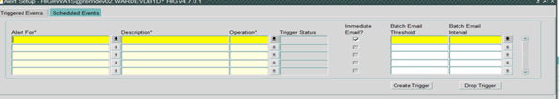

Figure5

**Bug Fix**

We need to create a new visual attribute (named 'READONLY') for setting the display of read only text fields with background color gray16. When the “Immediate Email?” Field is checked then the the Batch Email Threshold" and "Batch Email Interval fields are already marked read-only dynamically at runtime, we will also update the display of these fields to Read-only Fields.

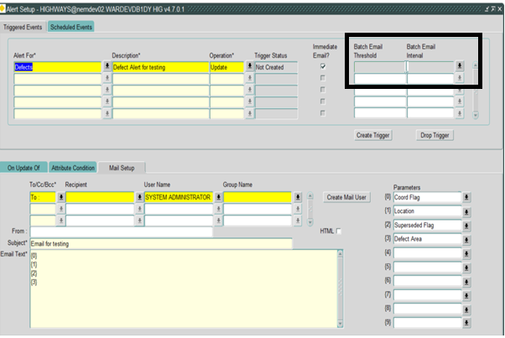

Figure6

**Analysis**

Form **HIG1520.fmb** would be updated to Grey out Batch Email Threshold" and "Batch Email Interval fields.

**Visual Attribute** Created:

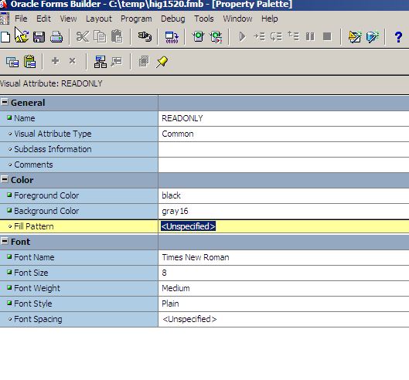

Figure7

## 2.4 [TFS: 68791](http://tfs.bentley.com:8080/tfs/ProductLine/Exor%20Products/_workitems#_a=edit&id=68791) “On Update Of” Tab to only appear on Update Operation

**Description**

HIG1520 - [General] Unclear error shown ("FRM-40200: Field is protected against update") when user tries to change attribute value in "On Update Of" tab in form HIG1520 (Alert Steup) with Operation other than Update.

**Bug Fix**

When the operation is other than Update the fields under “On Update Of” Tab are marked as Read-only. Hence the error.

To avoid confusion we shall update the form to not display “On Update Of” Tab when the Alert Operations are Other than Update

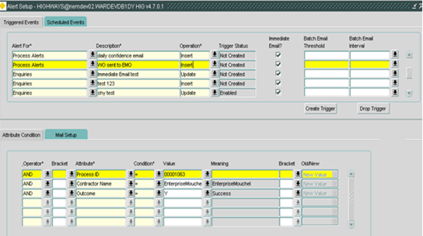

**Figure8**

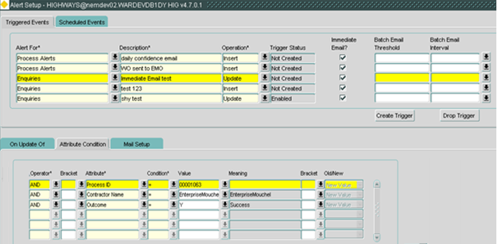

**Figure9**

**Analysis**

Form **HIG1520.fmb**

**PROCEDURE enable_disable_blk** is updatedto perform the needed action

## 2.5 [TFS: 112942](http://tfs.bentley.com:8080/tfs/ProductLine/Exor%20Products/_workitems#_a=edit&id=112942) Error received when deleting Alerts

**Description**

HIG1520 - Exor NET: Alert Setup: Alerts can’t be deleted. error ORA-0229: integrity constraint. *(SSE)*

**Bug Fix**

When we try to delete an Alert, if it has Alert Logs it throws an error.

To avoid it a fix has been generated where when you press X (delete a record) and then save, It would Prompt you that the Alert Logs will also be deleted and do you wish to Proceed. By Pressing No you can terminate the action. And Clicking on Yes would remove the Alert Logs and the Alert.

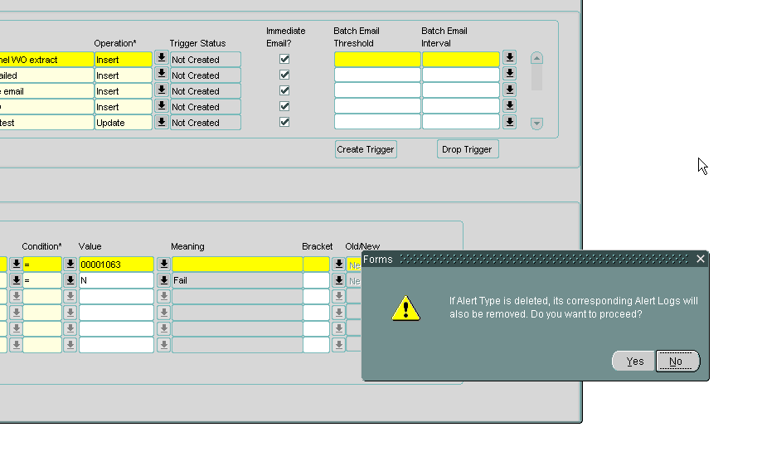

**Figure10**

**Analysis**

Creating a new Procedure to delete the records using BULK COLLECT to keep a check on Performance since count of Alert Logs can be huge and might take time to perform deletion.

Then Form **HIG1520.fmb** is add trigger an Alert, capture the response and take the needed action.

## 2.6 TFS: [85226](http://tfs.bentley.com:8080/tfs/ProductLine/Exor%20Products/_workitems#_a=edit&id=85226) & [99717](http://tfs.bentley.com:8080/tfs/ProductLine/Exor%20Products/_workitems#_a=edit&id=99717) on saving PEM error message is raised

**Description**

HIG1520 - [General] Alerts: If you fill Group name in alert setup form then appears "Value already exists" error message in Public Enquiries Bug Fix

HIG1520 - Exor Alert Setup: on saving PEM the error message is raised: HIG-0064 *(Northants)*

**Bug Fix**

To correct this issue we need to make a change in Trigger **hig_alert_recipients_a_ins**

For an Alert with multiple recipients, details are pushed into the hig_alert_recipient table. Which further populates doc_history table.

We need to modify the logic to insert into Doc_History if a record for PEM enquiry doesn’t exist. In case an entry is already present just append the new recipient to the existing value.

As of now we are inserting a separate record for each recipient.

Since the records are pushed in at same time and Enquiry Id is also same for each recipient, an error is received.

**Analysis**

**hig_alert_recipients_a_ins.trg** is updated to use merge rather than insert on doc_history

# Exor Select 2015

## 3.1 [TFS: 129356](http://tfs.bentley.com:8080/tfs/ProductLine/Exor%20Products/_workitems#_a=edit&id=129356) 10 new parameters into the alert email

**Description**

* + The requirement is to be able to pass more details as parameters into the alert email text.
  + The number of available parameters needs to be increased from 10 to 20

**Enhancement**

This fix would change look of the form. We will be adding 10 new field’s on HIG1520

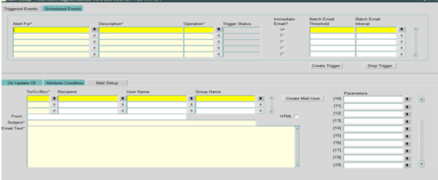

Figure 11

Additional parameter and derived columns would be added in the table HIG_ALERT_TYPE_MAIL

|  |  |  |  |
| --- | --- | --- | --- |
| Sr No | Column Name | Description | Data Type |
| Additional columns added to **HIG_ALERT_TYPE_MAIL** | | | |
| 1 | HATM_PARAM_11 | 10 new parameters | CHAR |
| 2 | HATM_PARAM_12 | CHAR |
| 3 | HATM_PARAM_13 | CHAR |
| 4 | HATM_PARAM_14 | CHAR |
| 5 | HATM_PARAM_15 | CHAR |
| 6 | HATM_PARAM_16 | CHAR |
| 7 | HATM_PARAM_17 | CHAR |
| 8 | HATM_PARAM_18 | CHAR |
| 9 | HATM_PARAM_19 | CHAR |
| 10 | HATM_PARAM_20 | CHAR |
| 11 | HATM_P11_DERIVED | These columns will be used to identify the parameter is Derived (i.e additional data) or from the existing Asset Type.  **NOTE** To be added only if fix for the TFS 79020 is released | CHAR |
| 12 | HATM_P12_DERIVED | CHAR |
| 13 | HATM_P13_DERIVED | CHAR |
| 14 | HATM_P14_DERIVED | CHAR |
| 15 | HATM_P15_DERIVED | CHAR |
| 16 | HATM_P16_DERIVED | CHAR |
| 17 | HATM_P17_DERIVED | CHAR |
| 18 | HATM_P18_DERIVED | CHAR |
| 19 | HATM_P19_DERIVED | CHAR |
| 20 | HATM_P20_DERIVED | CHAR |
| 10 | HATM_P10_DERIVED | CHAR |

Add Logic to pick value of these new fields and store them in their respective parameter columns added in HIG_ALERT_TYPE_MAIL table. Also update their HATM_Px_DERIVED columns with Y or N to understand if these are additional data fields.

**Analysis**

**Form : HIG1520.fmb**

**Package : HIG_ALERT.pkb**

* Fix would require a change in the Form to add 10 parameters under the Mail Setup Tab.
* Also additional logic needs to be added to handle the parameter’s both in form and package.

## 3.2 [TFS: 96373](http://tfs.bentley.com:8080/tfs/ProductLine/Exor%20Products/_workitems#_a=edit&id=96373) Attribute conditions sequence change after saving

**Description**

HIG1520 - Exor Core: [Alert Manager] after saving the Attribute conditions sequence is changed. *(Norfolk)*

**Bug Fix**

Add hatc_count column to table hig_alert_type_conditions.

|  |  |  |  |  |  |  |
| --- | --- | --- | --- | --- | --- | --- |
| Sr No | Column Name | | Description | | Data Type | |
| Alter Table **hig_alert_type_conditions** | | | | | | |
| 1 | | HATC_COUNT | | ORDER OF CONDITIONS | | NUMBER |

Display It on the form AS (Seq. No*) under Attribute Condition Tab to decide on Order of the Conditions and create a trigger.

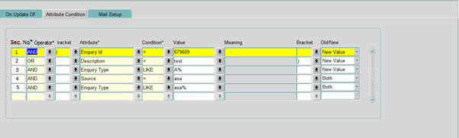

**Figure 12**

And then make necessary changes in package to pick the conditions in the order mentioned in the new column

**Analysis**

Package hig_alert.pkb Changes made to pick the conditions in the order mentioned in the new column

Form HIG1520.fmb Add a new column under Attribute Condition Tab.

Add hatc_count column to table hig_alert_type_conditions

**Work Around**

To remove all the conditions, Save it.

Add all new conditions.

## 3.3 [TFS: 85189](http://tfs.bentley.com:8080/tfs/ProductLine/Exor%20Products/_workitems#_a=edit&id=85189) 30 Second Alert: "Next Run Date" not populated

**Description**

HIG1520 - [General] Alerts: when you select 30 Second "Next Run Date" field is not populated.

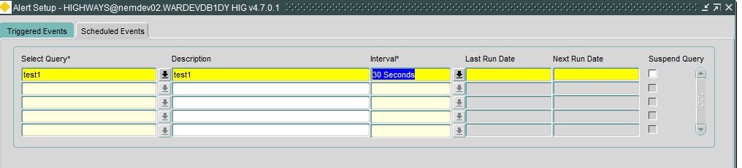

Figure13

**Bug Fix**

Calculate the date adding the seconds as per the interval selected. Currently we only have 30 Seconds Interval. But the fix has been made to display date for any Interval with seconds in 2 digit since when it becomes 60 seconds it would be counted 1 minute.

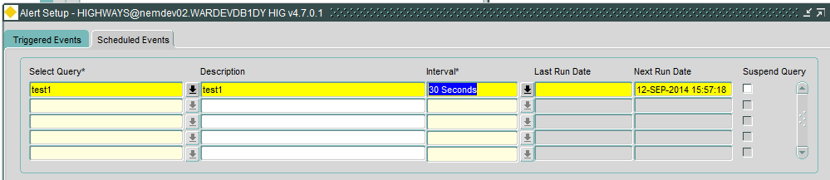

Figure14

**Analysis**

Package **HIG_Alert.pkb** would be updated to populate value of Next Run Date field when Interval is 30 Seconds .

**Suggestion**

Ideally interval in seconds should not be used since the whole Process would also take some time to run and having multiple runs in parallel can actually lead to deadlock

## 3.4 [TFS: 92732](http://tfs.bentley.com:8080/tfs/ProductLine/Exor%20Products/_workitems#_a=edit&id=92732) Sender to be picked from “From” field

**Description**

HIG1520 - [Alert manager] email sender should be picked from “FROM” field not from User account. (Wiltshire)

**Enhancement**

Change required in nm3mail package to not update the Return-Path with user currently logged in rather pick the sender and set it as Return-Path.

**Analysis**

Package **NM3MAIL.pkb** would be updated.

Currently in Function send_mail

utl_smtp.mail(g_mail_conn, l_sender_rec.sender_email);

Is used to set the return-path with the value we get from cursor cs_sender as the Current User. Now it needs to be replaced by the value of Sender passed to the function

Say

utl_smtp.mail(g_mail_conn, pi_mail_from);

**NOTE**

The change is in core package and would affect lot of functionalities currently running on it.

## 3.5 [TFS: 82703](http://tfs.bentley.com:8080/tfs/ProductLine/Exor%20Products/_workitems#_a=edit&id=82703) Email alerts don’t work for Internal Non Exor user in PEM(Northants)

**Description**

HIG1520 - Email alerts don’t work for Internal Non Exor user in PEM. *(Northants)*

Steps to reproduce:

1. In form HIG9130 (Product Options) query back ENQINTORG parameter. Set its value to EXOR. Save changes. See pct1.png
2. In form HIG1815 (Contacts) create user with e-mail address and organization value EXOR. See pct2.png
3. In form HIG1520 (Alert Setup) create Alert on inserting new enquiry as shown in pct3.png.
4. Open form DOC0150 create a new Pem which is assigned to the user created in step 2 and click save changes.

The error ORA-29277 Invalid SMTP operation will appear.

**Enhancement**

As per the technical document of Alert Manager:

The recipient can only come from nm_mail_users or nm_mail_groups.

Now to accommodate the Enquiry Contacts as recipient of Alert emails, would require a code change to verify them against ***hig_address, hig_contact_address, hig_contacts.***

**Analysis**

Package **HIG_ALERT.pkb** would be updated.

Currently we are verifying the recipient against nm_mail_users or nm_mail_groups.

Going forward if recipients are not available as a User then we shall verify if they match an Enquiry Contact created for an Internal Organization in hig_contact and its associated address tables.

Product Level Option **ENQINTORG** can be used to identify the Internal Organization Value.